Screenshots or program listings must be copied into appropriate cells in the following table.
Save this evidence document as evidence_ followed by your centre number_ candidate number, for example, evidence_ zz999_9999 and insert your name, centre number and candidate number into the header above.
Examiners must be able to read the contents including any screenshots without the use of a magnifying glass. Answers that are not readable or are missing will not be awarded any marks.
Save this evidence document at regular intervals, for example every 10 minutes.
Question 1
Part 1(a)
{#DECLARE Animals:ARRAY[0:9]OF STRING
global Animals
Animals=[]
}

Part 1(b)
{Animals.append("horse")
Animals.append("lion")
Animals.append("rabbit")
Animals.append("mouse")
Animals.append("bird")
Animals.append("deer")
Animals.append("whale")
Animals.append("elephant")
Animals.append("kangaroo")
Animals.append("tiger")
}

Part 1(c)
{def SortDescending():
ArrayLength=len(Animals)
for x in range(0,ArrayLength):
for y in range(0,ArrayLength-x-1):
if Animals[y][0:1]<Animals[y+1][0:1]:
Temp=Animals[y]
Animals[y]=Animals[y+1]
Animals[y+1]=Temp
}

Part 1(d)(i)
{SortDescending()
for x in range(10):
print(Animals[x])
}

Part 1(d)(ii)
{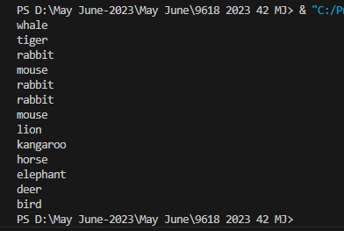 }

Question 2
Part 2(a)
{class SaleData():
#PUBLIC ID:STRING
#PUBLIC Quantity:INTEGER
def __init__(self,ID,Quantity):
self.ID=ID
self.Quantity=Quantity
}

Part 2(b)
{#DELCARE CircularQueue:ARRAY[0:4]OF SaleData
#DECLARE HeadPointer:INTEGER
#DECLARE TailPointer:INTEGER
#DECLARE NumberOfItems:INTEGER
global CircularQueue
global HeadPointer
global TailPointer
global NumberOfItems
CircularQueue=[]
for i in range(5):
CircularQueue.append(SaleData("",1))
print(CircularQueue)
HeadPointer=0
TailPointer=0
NumberOfItems=0
}

Part 2(c)
{def Enqueue(Record):
global CircularQueue
global TailPointer
global NumberOfItems
if NumberOfItems==5:
return -1
else:
CircularQueue[TailPointer]=Record
if TailPointer==4:
TailPointer=0
else:
TailPointer=TailPointer+1
NumberOfItems=NumberOfItems+1
return 1
}

Part 2(d)
{def Dequeue():
global CircularQueue
global NumberOfItems
global HeadPointer
if NumberOfItems==0:
return SaleData("",-1)
else:
ReturnData=CircularQueue[HeadPointer]
HeadPointer=HeadPointer+1
if HeadPointer>4:
HeadPointer=0
NumberOfItems=NumberOfItems-1
return ReturnData
}

Part 2(e)
{def EnterRecord():
userid=input("Enter The Id:")
userquantity=int(input("Enter The Quantity:"))
SaleRecord=SaleData(userid,userquantity)
Temp=Enqueue(SaleRecord)
if Temp==-1:
print("Full")
else:
print("Stored")
}

Part 2(f)(i)
{EnterRecord()
EnterRecord()
EnterRecord()
EnterRecord()
EnterRecord()
EnterRecord()
Temp=Dequeue()
if Temp.ID=="":
print("Queue is empty")
else:
print(Temp.ID +" "+ str(Temp.Quantity))
EnterRecord()
for x in range(5):
Records=CircularQueue[x]
print(Records.ID +" "+ str((Records.Quantity)))
}

Part 2(f)(ii)
{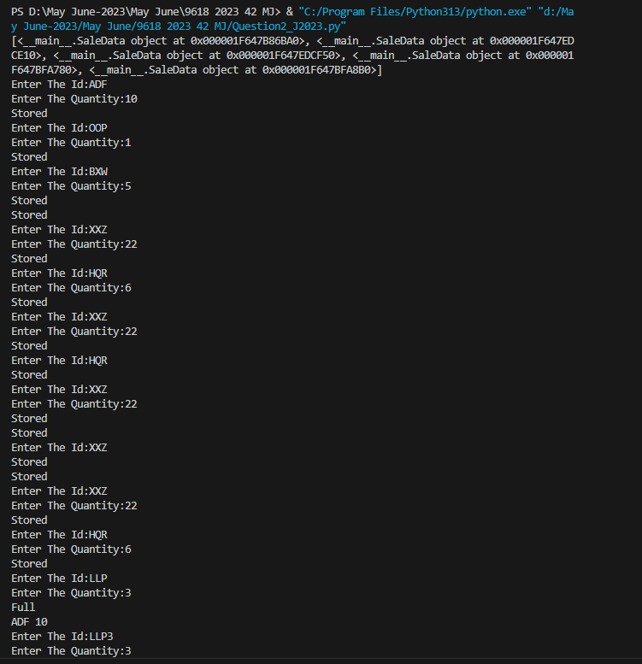 }

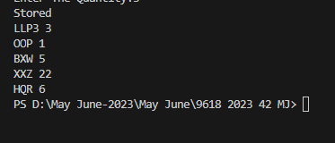

Question 3
Part 3(a)(i)
{class Employee():
#PRIVATE HourlyPay:REAL
#PRIVATE EmloyeeNumber:STRING
#PRIVATE JobTitle:STRING
#PRIVATE PayYear2022:ARRAY[0:51]OF REAL
def __init__(self,HourlyPay,EmployeeNumber,JobTitle):
self.__HourlyPay=HourlyPay
self.__EmployeeNumber=EmployeeNumber
self.__JobTitle=JobTitle
self.__PayYear2022=[0.0]*52
}

Part 3(a)(ii)
{ def GetEmployeeNumber(self):
return self.__EmployeeNumber
}

Part 3(a)(iii)
{ def SetPay(self,weeknumber,hoursworked):
Pay=float(self.__HourlyPay)*hoursworked
self.__PayYear2022[weeknumber-1]=Pay
}

Part 3(a)(iv)
{ def GetTotalPay(self):
Total=0
for x in range(len(self.__PayYear2022)):
Sum=self.__PayYear2022[x]
Total=Total+Sum
return Total
}

Part 3(b)(i)
{class Manager(Employee):
#PRIVATE BonusValue:REAL
def __init__(self, HourlyPay, EmployeeNumber, JobTitle, BonusValue ):
super().__init__(HourlyPay, EmployeeNumber, JobTitle)
self.__BonusValue=BonusValue
}

Part 3(b)(ii)
{ def SetPay(self,weeknumber,hoursworked):
TotalPay=hoursworked+(hoursworked*(self.__BonusValue/100))
super().SetPay(weeknumber,hoursworked)
}

Part 3(c)
{EmployeeArray = [Employee(0.0, "", "")] * 8

MaybeBonus=""
JobTitle=""
try:
EmployeeFile=open("Employees.txt","r")
for x in range(8):
hourlypay=float(EmployeeFile.readline().strip())
employeenumber=EmployeeFile.readline().strip()
MaybeBonus=EmployeeFile.readline().strip()
try:
Bonus=float(MaybeBonus)
JobTitle=EmployeeFile.readline().strip()
EmployeeArray[x]=Manager(hourlypay,employeenumber,JobTitle,Bonus)
except:
JobTitle==MaybeBonus
EmployeeArray[x]=Employee(hourlypay,employeenumber,JobTitle)
EmployeeFile.close()
except IOError:
print("File not found")
}

Part 3(d)
{def EnterHours():
try:
File=open("HoursWeek1.txt","r")
for x in range(8):
employeenumber=File.readline().strip()
hoursworked=float(File.readline().strip())
for y in range(8):
if EmployeeArray[y].GetEmployeeNumber() == employeenumber:
EmployeeArray[y].SetPay(1, hoursworked)
File.close()
except IOError:
print("File not found")
}

Part 3(e)(i)
{EnterHours()
for x in range(8):
print(EmployeeArray[x].GetEmployeeNumber(),str(EmployeeArray[x].GetTotalPay()))
}

Part 3(e)(ii)
{ 

